Name: | Debjit Ghosal
UID: | 20233000065
Experiment No. | Exp9B

AIM: | Exception Handling
Program 1
PROBLEM STATEMENT : | Define a class Cricketer which has:-  Attributes:-  ● player_name  ● runs_hit  ● innings_count  ● not_out_count  ● batting_avg  Methods:-get_avg  Make a cricket team with 11 cricketers. For each cricketer, find his batting  average. Handle all different errors while calculating this. Also, make a method  which will find the list of cricketers in ascending order of their batting average  and also display the cricketer stats in this order.  If the average of the batting average of the entire team is less than 20 runs then throw a user-defined exception.  Note- handle errors like ArrayIndexOutOfBoundsException, ArithmeticException,ArrayStoreException, NumberFormatException, etc
PROGRAM: | /* Write a java program for :  Define a class Cricketer which has:-  Attributes:-  ● player_name  ● runs_hit  ● innings_count  ● not_out_count  ● batting_avg  Methods:-get_avg  Make a cricket team with 11 cricketers. For each cricketer, find his batting  average. Handle all different errors while calculating this. Also, make a method  which will find the list of cricketers in ascending order of their batting average  and also display the cricketer stats in this order.  If the average of the batting average of the entire team is less than 20 runs then throw a user-defined exception.  Note- handle errors like ArrayIndexOutOfBoundsException, ArithmeticException,ArrayStoreException, NumberFormatException, etc  */  /*  FLow:  first make a class for exceptions  create class for cricketer  override class  make main class  */  import java.util.Scanner;  import java.util.Arrays;  class LowTeamBattingAverageException extends Exception {  public LowTeamBattingAverageException(String message) {  super(message);  }  }  class Cricketer {  String playerName;  int runsHit;  int inningsCount;  int notOutCount;  double battingAvg;  public Cricketer(String playerName, int runsHit, int inningsCount, int notOutCount) {  this.playerName = playerName;  this.runsHit = runsHit;  this.inningsCount = inningsCount;  this.notOutCount = notOutCount;  }  public double getAvg() {  if (inningsCount == 0) {  return 0.0;  }  return (double) runsHit / (inningsCount - notOutCount);  }  public String getPlayerName() {  return playerName;  }  public double getBattingAvg() {  return battingAvg;  }  @Override  public String toString() {  return "Player Name: " + playerName +  ", Runs Hit: " + runsHit +  ", Innings Count: " + inningsCount +  ", Not Out Count: " + notOutCount +  ", Batting Average: " + battingAvg;  }  }  public class CricketerFinal {  public static void main(String[] args) {  Cricketer[] team = new Cricketer[11];  team[0] = new Cricketer("Player1", 500, 20, 2);  team[1] = new Cricketer("Player2", 600, 25, 3);  team[2] = new Cricketer("Player3", 300, 35, 6);  team[3] = new Cricketer("Player4", 600, 25, 8);  team[4] = new Cricketer("Player5", 600, 45, 6);  team[5] = new Cricketer("Player6", 600, 15, 8);  team[6] = new Cricketer("Player7", 600, 75, 4);  team[7] = new Cricketer("Player8", 600, 65, 6);  team[8] = new Cricketer("Player9", 600, 55, 3);  team[9] = new Cricketer("Player10", 600, 5, 1);  team[10] = new Cricketer("Player11", 600, 45, 6);  try {  double teamAvg = 0.0;  int playerCount = 0;  for (Cricketer player : team) {  if (player != null) {  player.battingAvg = player.getAvg();  teamAvg += player.getBattingAvg();  playerCount++;  }  }  if (playerCount != 0) {  teamAvg /= playerCount;  }  if (teamAvg < 20) {  throw new LowTeamBattingAverageException("Team's average batting average is below 20 runs.");  }  Arrays.sort(team, (a, b) -> Double.compare(a.getBattingAvg(), b.getBattingAvg()));  System.out.println("Cricketers sorted by batting average:");  for (Cricketer player : team) {  if (player != null) {  System.out.println(player);  }  }  } catch (LowTeamBattingAverageException e) {  System.out.println("Error: " + e.getMessage());  } catch (ArithmeticException | NullPointerException | ArrayIndexOutOfBoundsException | ArrayStoreException | NumberFormatException e) {  System.out.println("Error: " + e.getClass().getSimpleName() + " occurred while calculating batting average.");  }  }  }
RESULT:
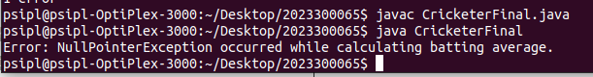
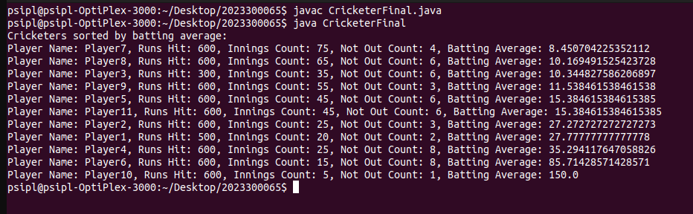
Program 2
PROBLEM STATEMENT : | Write a program to implement stack operations:  a.Push b. Pop  Write a user defined exception to check whether the stack is full or  empty.
PROGRAM: | /*  Write a java program to implement stack operations:  a.Push b. Pop  Write a user defined exception to check whether the stack is full or  empty.  */  /*  Flow:  User-defined exception for stack full condition  User-defined exception for stack empty condition  Stack implementation using array  then use constructor  the use the push and pop operations  Main class to demonstrate stack operations  */  import java.util.Scanner;  class StackFullException extends Exception {  public StackFullException(String message) {  super(message);  }  }  class StackEmptyException extends Exception {  public StackEmptyException(String message) {  super(message);  }  }  class Stack {  private int maxSize;  private int[] stackArray;  private int top;  public Stack(int size) {  maxSize = size;  stackArray = new int[maxSize];  top = -1;  }  public void push(int value) throws StackFullException {  if (top == maxSize - 1) {  throw new StackFullException("Stack is full");  }  stackArray[++top] = value;  }  public int pop() throws StackEmptyException {  if (top == -1) {  throw new StackEmptyException("Stack is empty");  }  return stackArray[top--];  }  }  public class Push_Pop {  public static void main(String[] args) {  Stack stack = new Stack(5);  try {  stack.push(10);  stack.push(20);  stack.push(30);  stack.push(40);  stack.push(50);  stack.push(60);  System.out.println("Popped element: " + stack.pop());  System.out.println("Popped element: " + stack.pop());  System.out.println("Popped element: " + stack.pop());  System.out.println("Popped element: " + stack.pop());  System.out.println("Popped element: " + stack.pop());  } catch (StackFullException e) {  System.out.println("Error: " + e.getMessage());  } catch (StackEmptyException e) {  System.out.println("Error: " + e.getMessage());  }  }  }
RESULT:
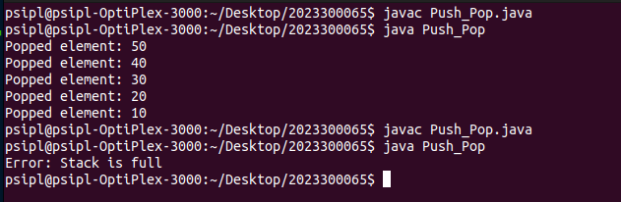
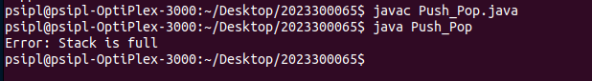
CONCLUSION: | I have learnt about exception handling and a more about the push and pop operations.

